Basic knowledge assignment

**Made by:** Tim Chermin

**Version:** 2.3

**Date:** 11/04/2020

Table of Contents

Version 3

Introduction 4

My company 5

Introduction into Defensive IT and Information Security Concepts 6

Prior knowledge 6

Task 6

What have I learned? 6

Security incident management 7

Prior knowledge 7

Task 7

What have I learned? 8

Network Separation and Segmentation (Firewalls) 9

Prior knowledge 9

Setup pfSense 9

What have I learned? 12

Secure Network Connections (HTTPS/TLS/SSH) 13

Prior knowledge 13

HTTPS (Roijers, From crypto till HTTPS, 2020) 13

SSH (Roijers, Safe network connections exercise, 2020) 14

What have I learned? 14

IDS 15

Prior knowledge 15

Task 15

What have I learned? 17

VPN 18

Prior knowledge 18

Task 18

What have I learned? 20

IT Monitoring 21

Prior knowledge 21

Task 21

What have I learned? 23

Overall Conclusion 24

Reflection 24

Bibliography 25

Notes: 27

# Version

|  |  |  |  |  |
| --- | --- | --- | --- | --- |
| **Version** | **Autor** | **Date** | **Changes** | **Time spend** |
| 1.0 | Tim Chermin | 13/02/2020 | * Basic setup | 10 min |
| 1.1 | Tim Chermin | 06/03/2020 | * [Firewall setup](Tim_Chermin_CSB_Basic_Knowledge_Assignment.docx#Network Separation and Segmentation (Firewalls)) | 6 hours |
| 1.2 | Tim Chermin | 12/03/2020 | * [Security incident management](Tim_Chermin_CSB_Basic_Knowledge_Assignment.docx#Security incident management) | 5 hours |
| 1.3 | Tim Chermin | 13/03/2020 | * Continuation of the firewall setup | 6 hours |
| 1.4 | Tim Chermin | 15/03/2020 | * Document the process of Friday * Added TODO | 3 hours |
| 1.5 | Tim Chermin | 20/03/2020 | * [Start https and ssh](Tim_Chermin_CSB_Basic_Knowledge_Assignment.docx#Secure Network Connections (HTTPS/TLS/SSH)) * Add information to firewall | 7 hours |
| 1.6 | Tim Chermin | 21/03/2020 | * Finish https and ssh * [Finish CIA matrix](Tim_Chermin_CSB_Basic_Knowledge_Assignment.docx#My company) | 5 hours |
| 1.7 | Tim Chermin | 27/03/2020 | * Start IDS * Start VPN | 8 hours |
| 1.8 | Tim Chermin | 28/03/2020 | * Finish IDS * Continue VPN | 6 hours |
| 1.9 | Tim Chermin | 02/04/2020 | * Continue VPN | 5 hours |
| 2.0 | Tim Chermin | 03/04/2020 | * Finish VPN * Start IT Monitoring | 7 hours |
| 2.1 | Tim Chermin | 04/04/2020 | * Added VPN to document * Wrote reflection * Added a bit more explanation in some parts | 3 hours |
| 2.2 | Tim Chermin | 09/04/2020 | * Started with prior knowledge and what I learned for each subject. | 4 hours |
| 2.3 | Tim Chermin | 10/04/2020 | * Finished with prior knowledge and what I learned for each subject. * A bit of clean-up * Removed TODO | 2 hours. |

# Introduction

Before this semester I already had some experience since I did the CSA-course before CSB. I did not know much about the defensive side of things though. I really liked style 1 when I did the CSA course, so I decided I will be doing the same for CSB.

In this document, I have documented everything I learned this semester and how I learned it.

My main goal was to learn the basics of the defending site of cyber security. I will try to use as much of the knowledge I gained when following the CSA course in this course.

# My company

I use the company found on canvas.

“The example design is based on company X, a small company with about 10 employees that hosts web-sites for their customers. They provide so-called virtual hosting in the Company X DMZ to serve the Internet (WAN). They also run their own company X web site in the same environment. DNS-service is also provided here. Internally (LAN), they host internal services like a Windows domain controller for managing user accounts, corresponding security policies and eventually hosting an internal DNS service. Both networks DMZ and LAN contain an IDS-sensor that detects specific intrusions and hacking attempts. The LAN (users and internal servers use the same network) also contains a monitoring server.” (explanation basic knowledge assignment, n.d.)

The image bellow shows the network I am going to try to setup. The one on the left is the template and the one on the right is the template with my IPs.

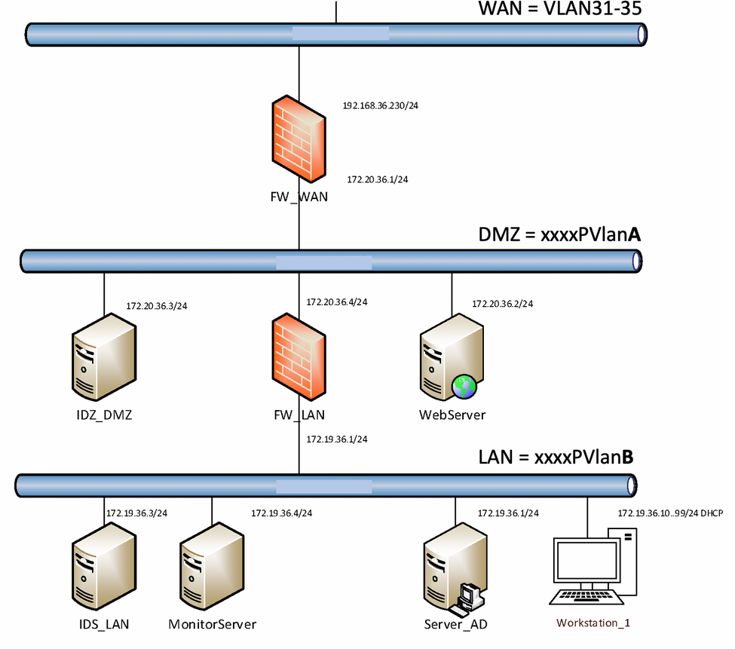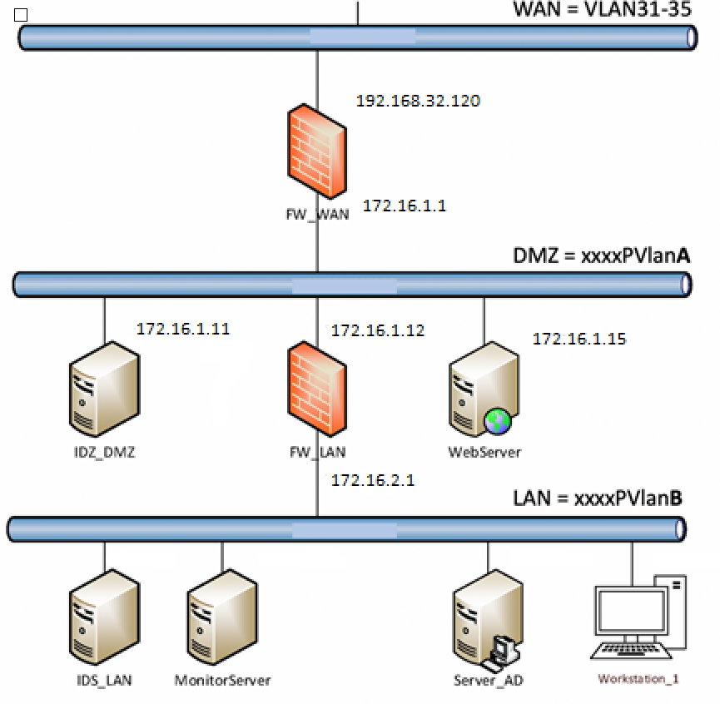

## Introduction into Defensive IT and Information Security Concepts

## Prior knowledge

I didn’t know anything about CIA before this subject. I didn’t really understand what was meant with Confidentiality and Integrity at first but reading the canvas page helped with understanding this a lot.

## Task

CIA stands for Confidentiality, Integrity and Availability (Wikipedia, 2020)  
I started with reading through the Wikipedia page and the canvas page. (Fontys, n.d.) with that I was able to fill in the CIA for my company.

**Confidentiality** “is the property, that information is not made available or disclosed to unauthorized individuals, entities, or processes.” (Wikipedia, 2020)

**Integrity** “data integrity means maintaining and assuring the accuracy and completeness of data over its entire lifecycle. This means that data cannot be modified in an unauthorized or undetected manner.” (Wikipedia, 2020)

**Availability** “the computing systems used to store and process the information, the security controls used to protect it, and the communication channels used to access it must be functioning correctly.” (Wikipedia, 2020)

|  |  |  |  |
| --- | --- | --- | --- |
| **Dimension** | **Attribute** | **Threat** | **Relevance for Example Company** |
| **Confidentiality** | Exclusiveness | Disclosure | Machine access could be compromised |
|  | Exclusiveness | Abuse | Compromised machines could be exploited |
| **Integrity** | Correct | Tampering | User data could be changed by hackers |
|  | Complete | Removal | Data could be deleted by hackers |
|  | Complete | Addition | Data could be added by hackers |
|  | Valid | Out of date | Out of date systems within the network could be exploited |
|  | Authentic | Forgery | Fake data could be added by hackers |
|  | Indisputability | Denial | Access is denied meaning users can’t access certain things within the network |
| **Availability** | Well timed | Delay | Delays in the system could cause software conflicts |
|  | Continuity | Downtime | Downtime could lead to user unsatisfaction and non-working employees, meaning losing a lot of money |

## What have I learned?

I had to do a decent amount of reading for this subject and it helped me understand the threats that a company has a bit better. With some obvious thinking I was able to write down what kind of threats a company can get and how it would be relevant.

# Security incident management

## Prior knowledge

I knew a bit about Security incident management before this subject. But this was mostly just a bit of common knowledge, for example it makes sense to prepare and prevent incidents from happening in the first place. Using the instruction, the canvas page, the Wikipedia page (Wikipedia, 2020) and the cybersecurity resources page (Gale, 2016) I was able to get a better understanding of this subject.

## Task

Attackers try to breach the network by targeting unsecured ports, penetrating network security, or abusing network access.

1. **Alert reception:**

A security alert should come from the monitoring systems, or from a service desk. (reference security incident management, n.d.) From here the company can further analyse the alert and act if the incident is a security incident.

**Best practices:**

Track connections to your network from the outside to detect intrusions, compromises, malicious software, and even users abusing network access.

Log network flow to record access to and from the internet.

Apply Network Behaviour Anomaly Detection and Network Behaviour Analysis.

So, in my company the monitoring systems and operators in a Security Operations Centre (SOC) should detect an issue. When the attack happens, they will then start with the second phase.

2**. Alert Triage and prioritization.**

Triage is the first step to take, after first detection or reception of a security alert. In triage you gather information to be able to determine if the alert is a real incident or a false positive and what the severity and impact of the incident is. From that you determine the priority.  
There are 3 steps in the triage:

1. categorise the incident. How severe is it and what are the potential impacts?  
2. Prioritise. Does this require an urgent escalation, or can it be easily resolved?  
3. Assignment. Who is responsible managing and resolving the incident, and by when?

Traffic from compromised servers may leave distinctly visible patterns, which can be analysed for information or used to mitigate an attack. Identifying this type of traffic can help with the response of the company before data is lost or damaged.

3. **Respond:**

The response can have different types of communication which can all be important.

**The technical response:** This can include analysing the incident, advising on or planning a resolution, co-ordinating actions internally and externally, containing any on-going malicious activity, repairing or recovering any affected systems. With advice from your technology/service provider or accredited IT security consultant may be required.

**Management response:** focuses on activities such as notifying staff and affected customers of a breach and advising of steps taken to resolve the situation, approving courses of action and other communications.

**Legal response:** If the incident involves fraud or cybercrime you should report the incident to the police.

4. **Close the incident and review:**after the incident a review must be done to see if any further actions must be taken to minimize the risk of the incident occurring again.

**Attack 1: Network breach and database access.**

1. **categorise the incident. How severe is it and what are the potential impacts?**With the monitoring of the network through pre-setup applications, the SOC team will know that the network has been breached that the attackers have access to the database. Meaning it is very severe and the potential impacts are huge. Once they have access to the network and database, they could delete valuable data.

2. **Prioritise. Does this require an urgent escalation, or can it be easily resolved?**  
This problem would require a quick response since it can deal a lot of damage to the whole company and all its users.

3. **Assignment. Who is responsible managing and resolving the incident, and by when?**This incident should be solved as fast as possible. The SOC team will inform, the people who maintain the database, the people who maintain the network and the lead of the applications/company. If any user data has been stolen, the company should also inform the police about the incident.

**Attack 2: Port scan detected.**

1. **categorise the incident. How severe is it and what are the potential impacts?**The problem is not severe at all since the scanning of ports itself isn’t something with a huge impact.

2. **Prioritise. Does this require an urgent escalation, or can it be easily resolved?**   
This is not an urgent problem at all since it is not really a in the short run. But it would be wise to keep the most important ports in check.

3. **Assignment. Who is responsible managing and resolving the incident, and by when?**

This incident can mostly just be neglected by the company.

## What have I learned?

I learned that some “incidents” aren’t worth to waste time on, while other incidents are way more dangerous. I didn’t expect there to be incidents that weren’t as important to check as others. I also learned about all the different steps that a company must take when a possible incident is detected.

# Network Separation and Segmentation (Firewalls)

## Prior knowledge

I had a bit of network knowledge before, but I had never setup my own and I also didn’t really know much about setting up firewalls. It took me some time to understand how PfSense works and what to connect to what.

## Setup pfSense

By following the guide (Roijers, Firewalls, proxies and application level filtering, 2020) the canvas course (Fontys, n.d.) and the style 1 instruction is started with the pfSense setup.

“pfSense is a free firewall, router and vpn server. The pfSense system is based on the open source UNIX (FreeBSD). Configuration and management of pfSense can be performed using clear interfaces, so specific FreeBSD knowledge is typically not required.” (Studentenplein, n.d.)

First, I added these templates (seen in the images bellow) and gave them the network adapters to align with the network design of my company. That means that my first PfSense is going to be connected to WAN (Vlan 34) and DMZ (PVlan A). My second PfSense is connected to DMZ and LAN (PVlan B) to edit my firewall rules I connected a Kali template to DMZ and a windows10 template to LAN. And after all that I added an Ubuntu server template to DMZ as seen in the network design of my company.  
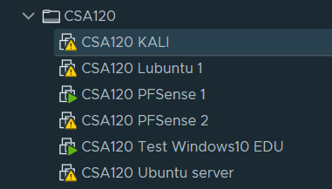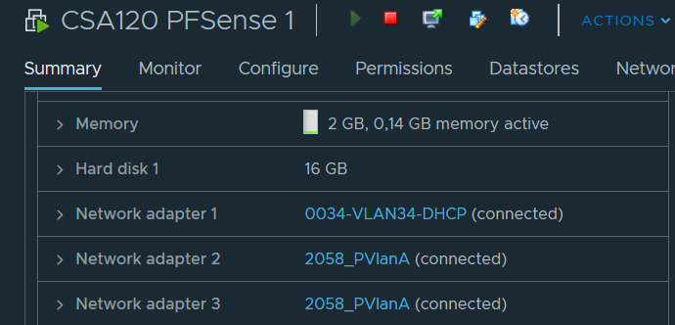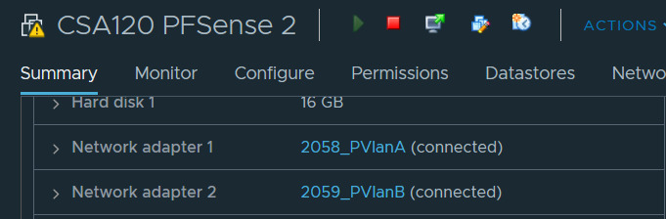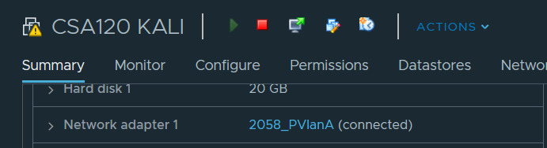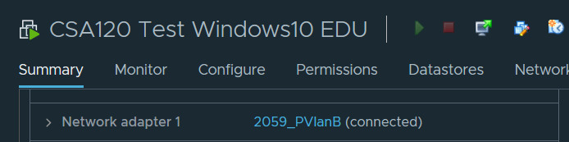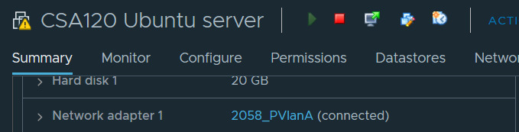

I later changed my windows10 from VlanB to VLAN-32 when I setup the OpenVPN in it. With this I was able to access VlanB from VLAN-32. (See the vpn section of this document)

Once the setup of the templates was done, I continued with the PfSense setup.

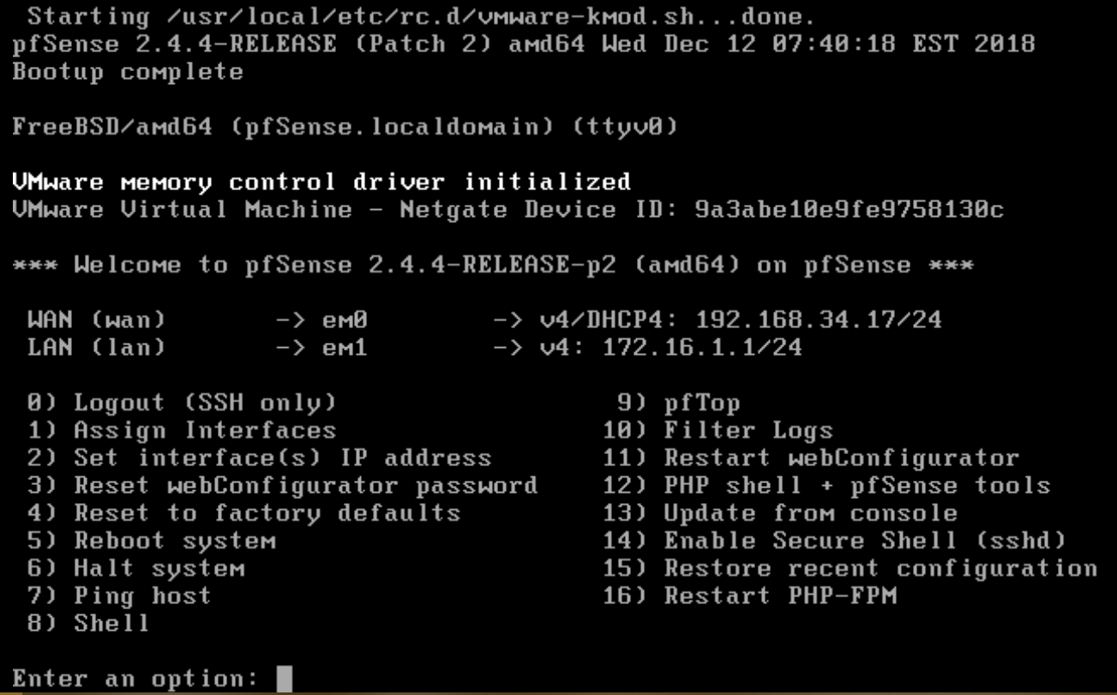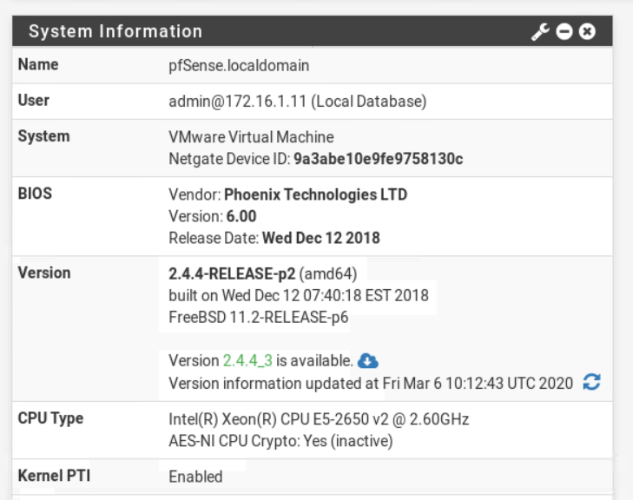

I later had to change the WAN IP since we got an announcement that we had to assign our is by our CSANr which is CSA120 for me. And I also had to be on VLAN32 instead of VLAN34, So I changed it to 192.168.32.120 by this time I had also already changed the LAN name to DMZ as seen in the image bellow. (Other pictures may still show LAN though!!!!)



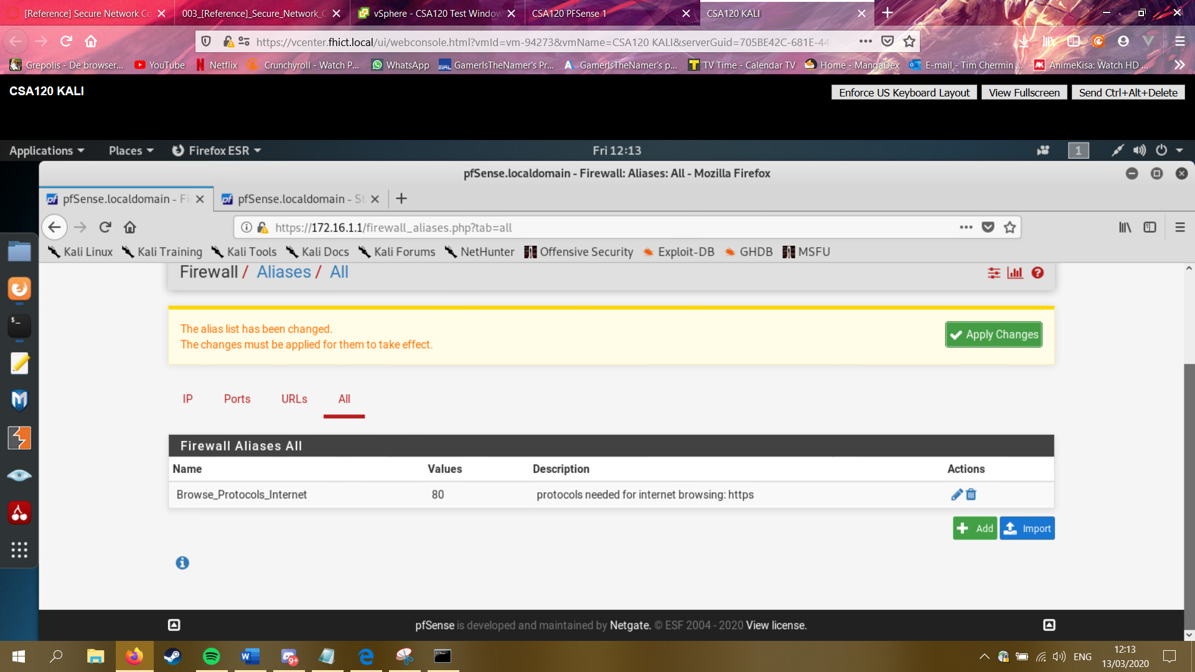

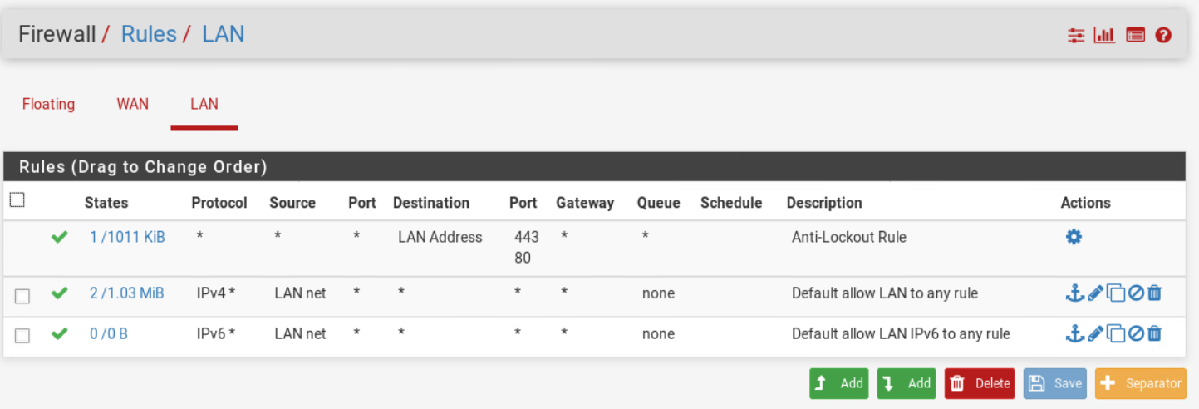

With that I was able to see my firewall rules as seen in the image above. But I needed to add and remove some of these rules since it now just grants access to everything.

At first, I also had no idea what everything meant, but thankfully it explains itself when adding rules.

|  |  |
| --- | --- |
| Definition firewall rule | |
| Action | You can allow something to pass, block or reject. Difference between block and reject Is that with reject a packet (TCP RST or ICMP port unreachable for UDP) is returned to the sender, whereas with block the packet is dropped silently. In either case, the original packet is discarded. |
| Interface | The interface from which packets must come to match this rule |
| Protocol | Which IP protocol this rule should match |
| Source – Type | Where it’s from |
| Destination | Where it’s going to |
| Destination port range | Enter the previously defined alias name in the red 'from' and 'to' fields. |
| Description | The description of the rule |

I started with adding an allow to ping to the wan rules, with this I will be able to see if it still works.

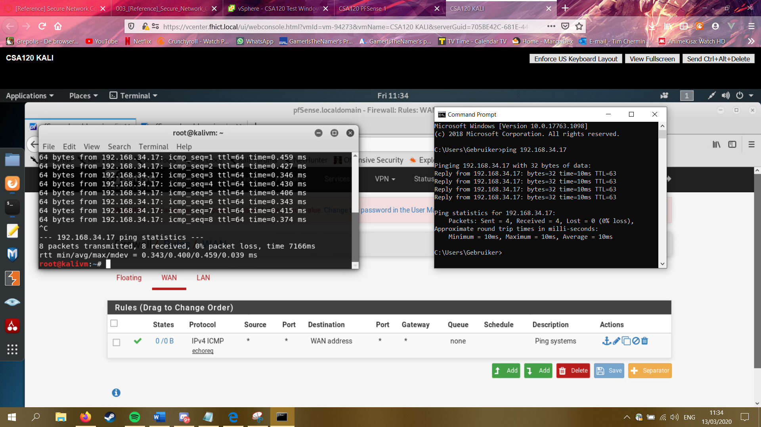

In the end I had the rules as seen in the images bellow:

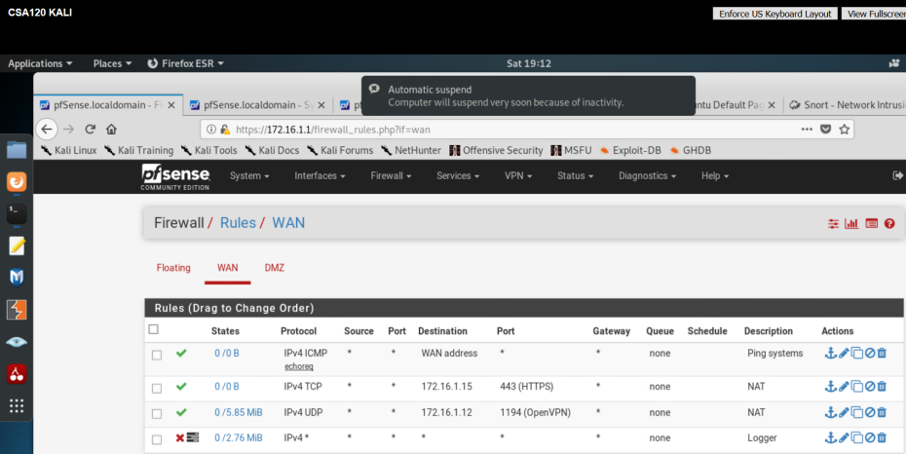

All I did was setup a logger that would log everything that I didn’t allow. I did allow HTTPS and OpenVPN. I allowed HTTPS for my webserver and I allowed OpenVPN for getting to the LAN.

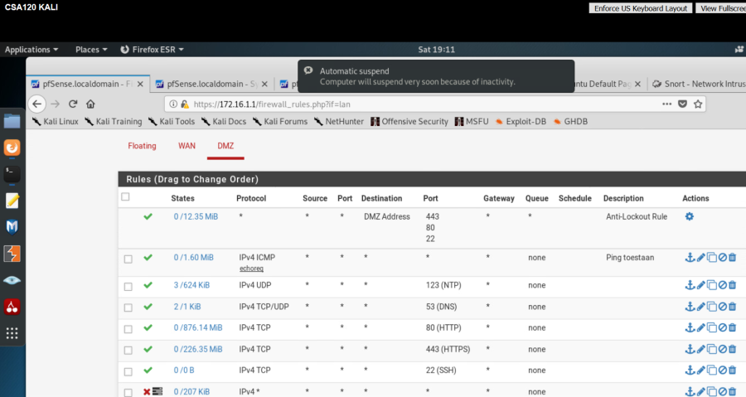

I removed both the Allow all from WAN and DMZ since I don’t want to allow everything. I didn’t add much for my WAN, but I added a decent amount for my DMZ. I wanted users to browse http and https I also wanted the times on my webserver to sync to I added NPT. I also needed ssh to reach my webserver with ssh. And lastly, I added DNS for better readability.

I also setup the second firewall.



## What have I learned?

I learned about the basics of firewall rules and how-to setup pfSense. At first it took me way too long to understand the basics but after doing other subjects I started to understand this one a bit better. Also seeing results when allowing or not allowing a rule helped with figuring out which rules, I should add.

# Secure Network Connections (HTTPS/TLS/SSH)

## Prior knowledge

I knew what https does on a site by following the CSB course, but I didn’t know how to get it to work on my webserver. I didn’t really know anything about ssh before I started this.

## HTTPS (Roijers, From crypto till HTTPS, 2020)

When all that firewall setup was done for now, I tried the Secure Network Connections (HTTPS/TLS/SSH) the first time I did something wrong and I had to do it over again. But as seen in the images bellow, I finally got it to work.

All I had to do was follow the instruction and basically copy paste the commands from a site to my ubuntu server.

I then tried to see if it worked and I was able to see my csa120.com is seen in the certificate.

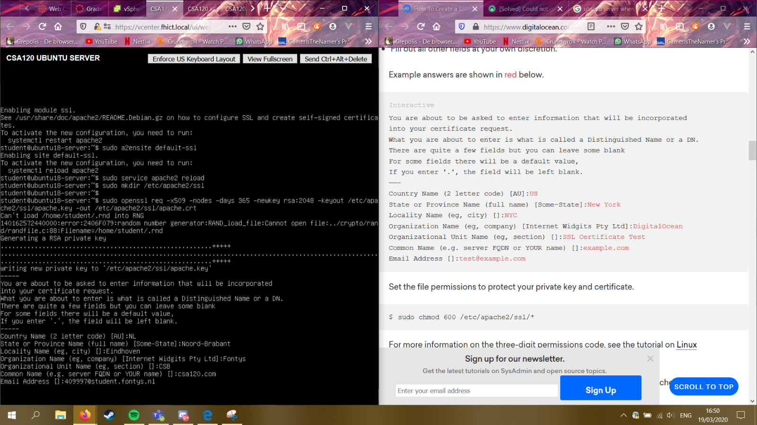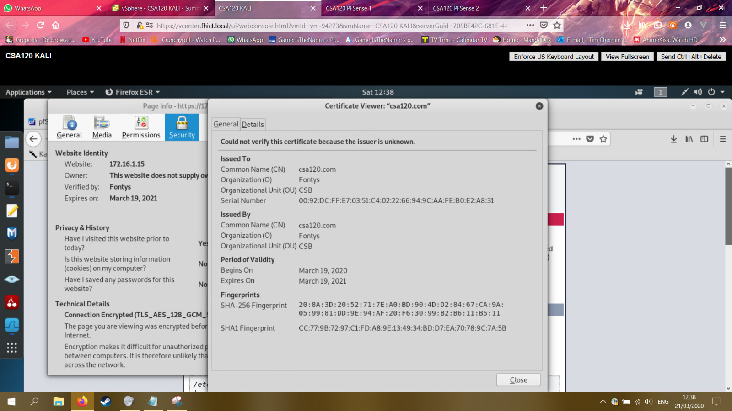

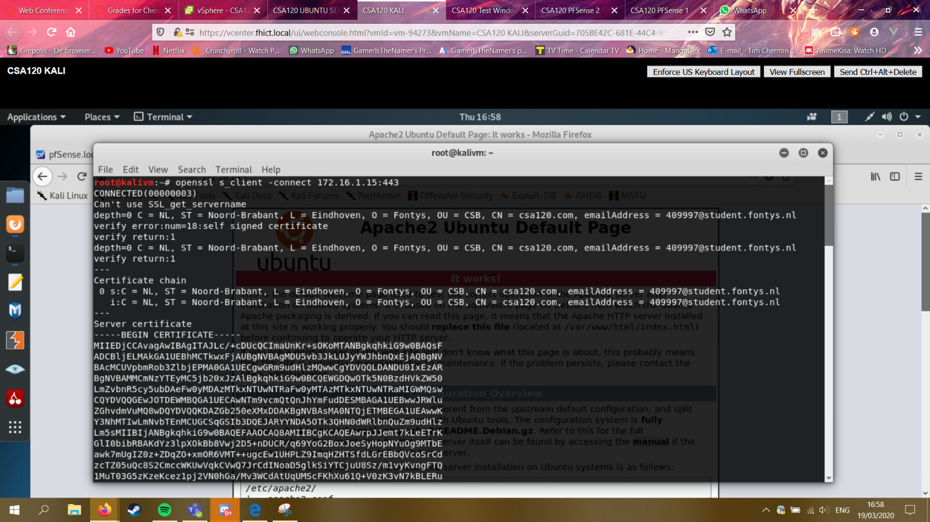

I was also able to reach my webserver from the outside by going to 192.168.32.120.

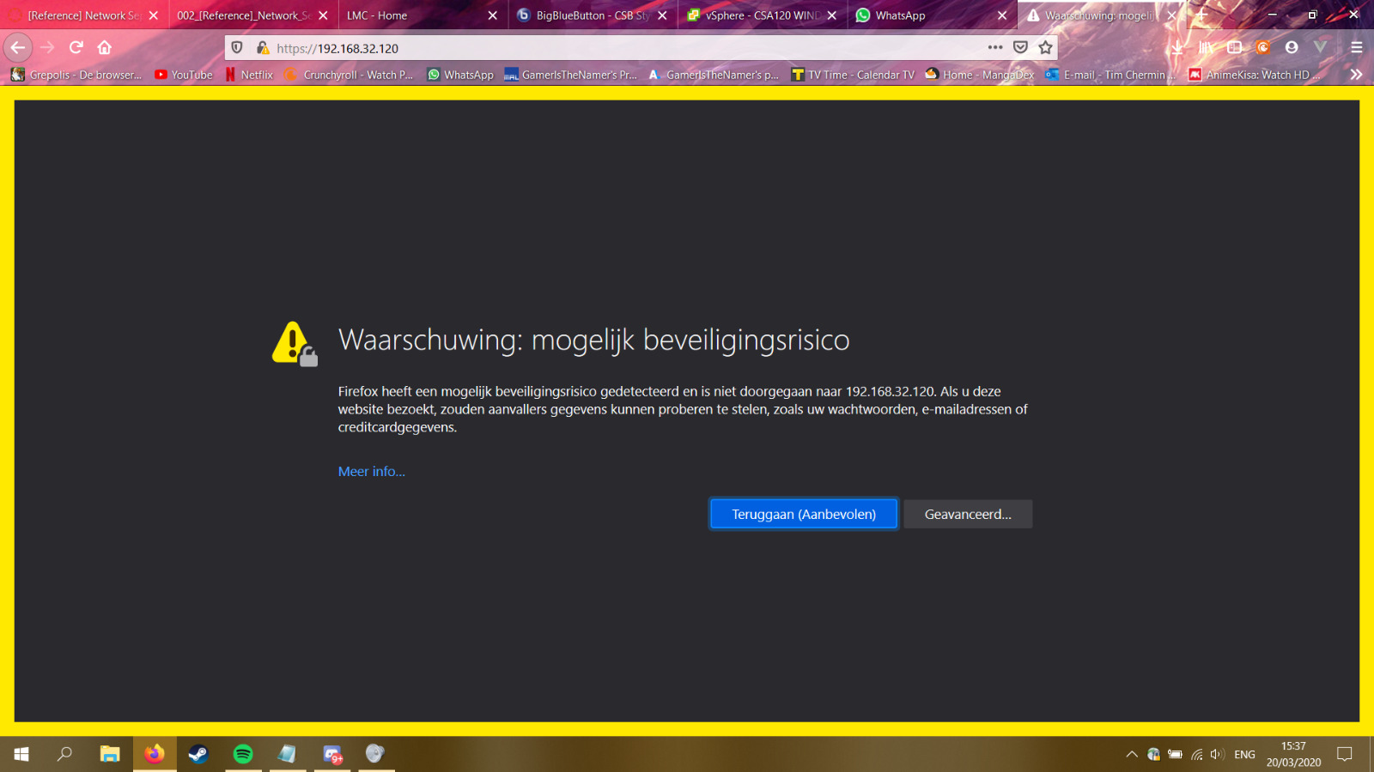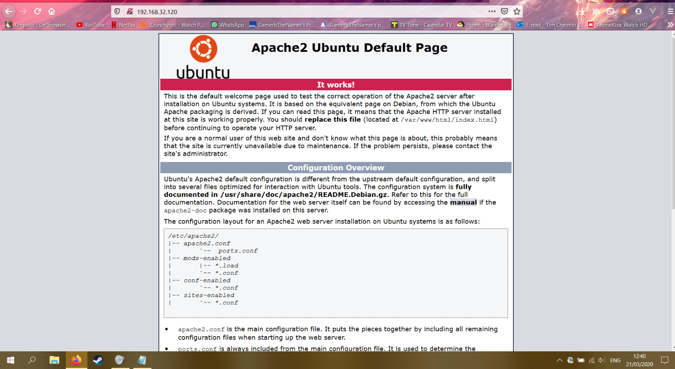

## SSH (Roijers, Safe network connections exercise, 2020)

This was probably one of the easiest things to setup since all I had to do was install ssh on my webserver and then login by using the ssh command from my Linux template.

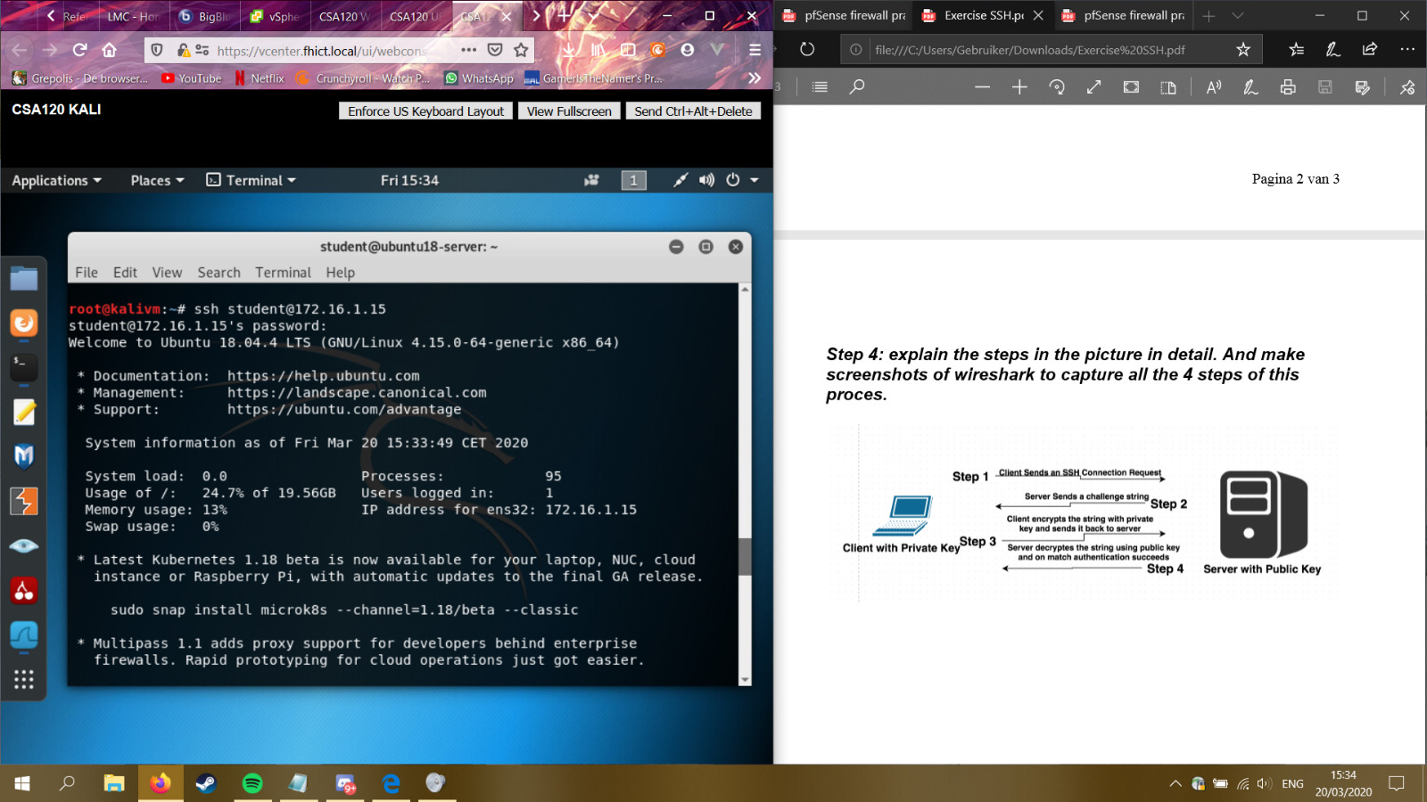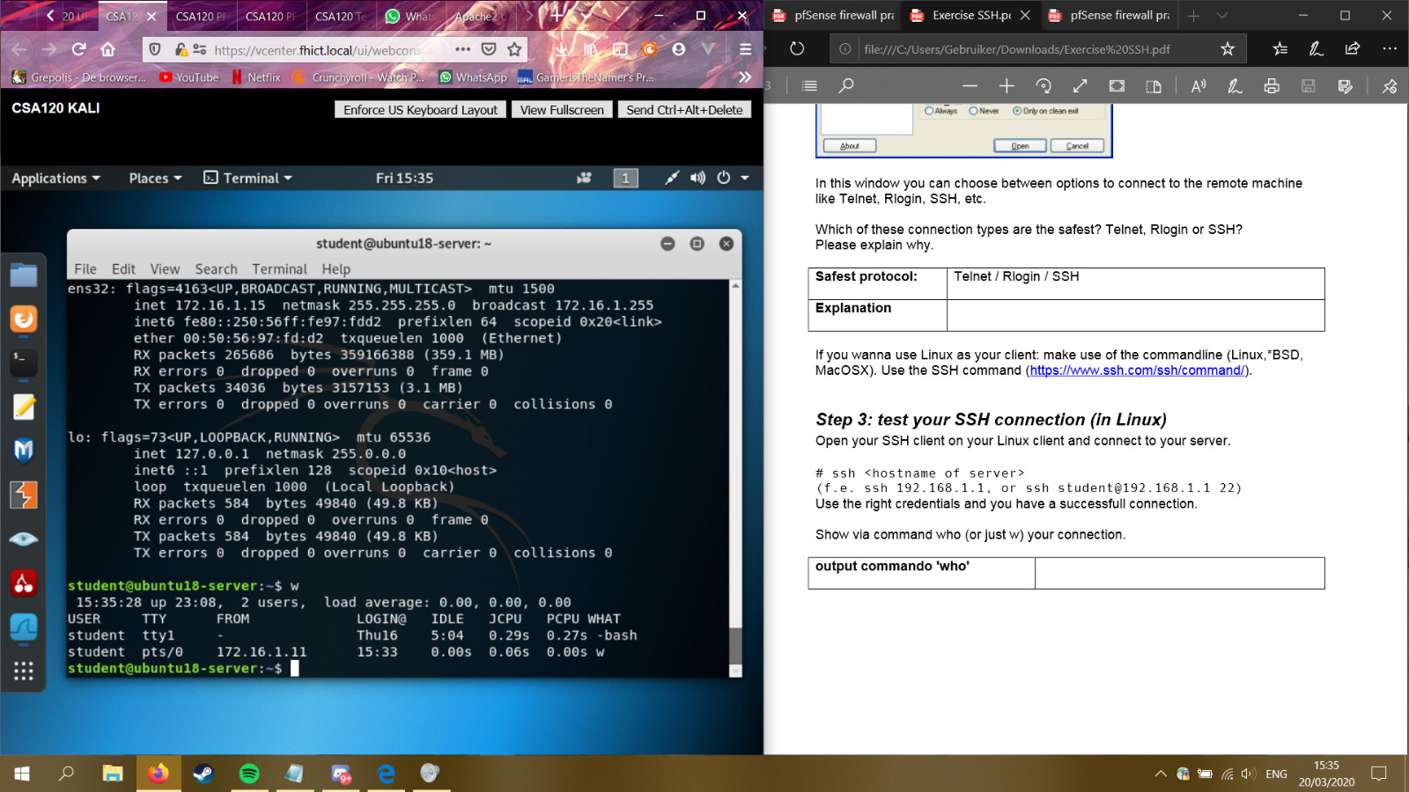

Since this was done so quickly, I also wanted to try the same by using PuTTY on windows.

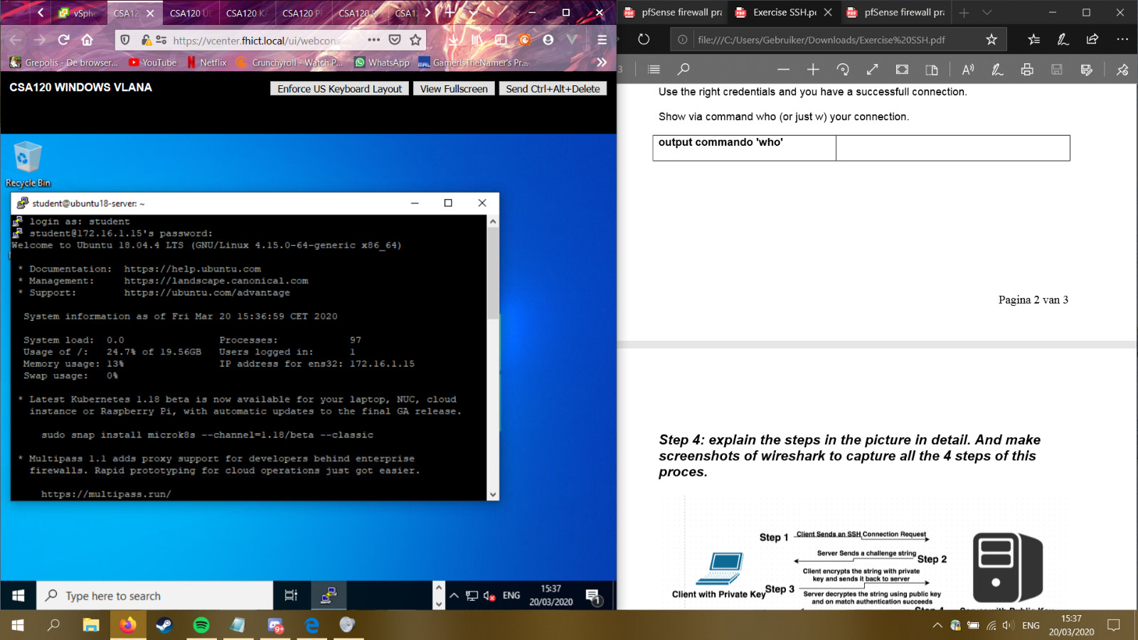

I was also able to see the connection in Wireshark as seen in the image bellow.

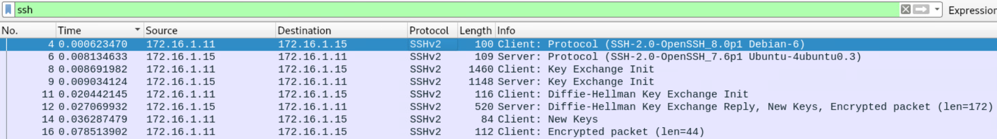

## What have I learned?

I learned how to setup https and ssh for my webserver and I learned that it was easier to setup that I thought it would be. I had not tried to sniff a ssh connection yet, so I also learned how to do that.

# IDS

## Prior knowledge

I knew nothing about intrusion detection systems before I started this subject, except for the fact that they exist and that they detect intrusions. I did not know how to set them up though.

## Task

**IDS:** Intrusion detection system “is a device or software application that monitors a network or systems for malicious activity or policy violations” (Fontys, n.d.) these systems can be dived in NIDS and HIDS.

**NIDS:** Network intrusion detection systems are systems that “detect hacking activities, denial of service attacks or port scans on a computer network or a computer itself” (Computer Hope, 2017)

**HIDS:** Host-based intrusion detection systems “is an intrusion detection system that is capable of monitoring and analysing the internals of a computing system as well as the network packets on its network interfaces, similar to the way a network-based intrusion detection system (NIDS) operates.” (wikipedia, 2019)

**IPS:** Aside from the detection systems you also have intrusion prevention systems or IPS in short. These obviously try to prevent intrusions.

The main difference between IDS and IPS is what they do when they detect an incident. For example, the IPS control the access to a network and protect it. The systems take necessary action to prevent an attack from developing. While intrusion detection systems are not designed to deny attacks! They simply check the network and send alerts.

One again, by just following the guide on canvas I was able to setup the IDS.

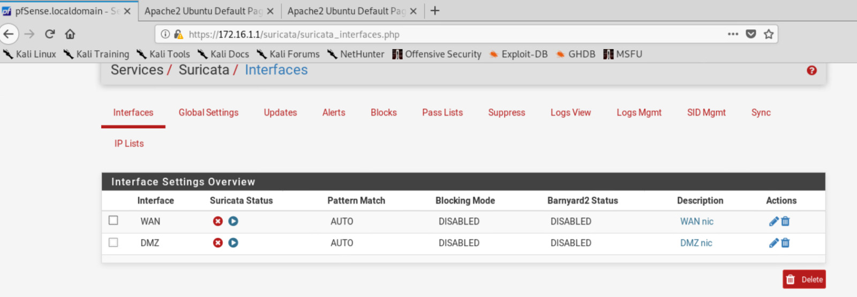

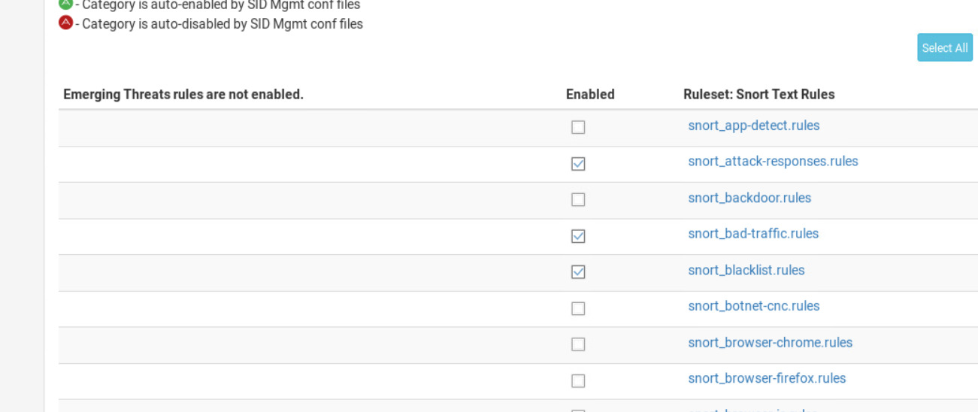

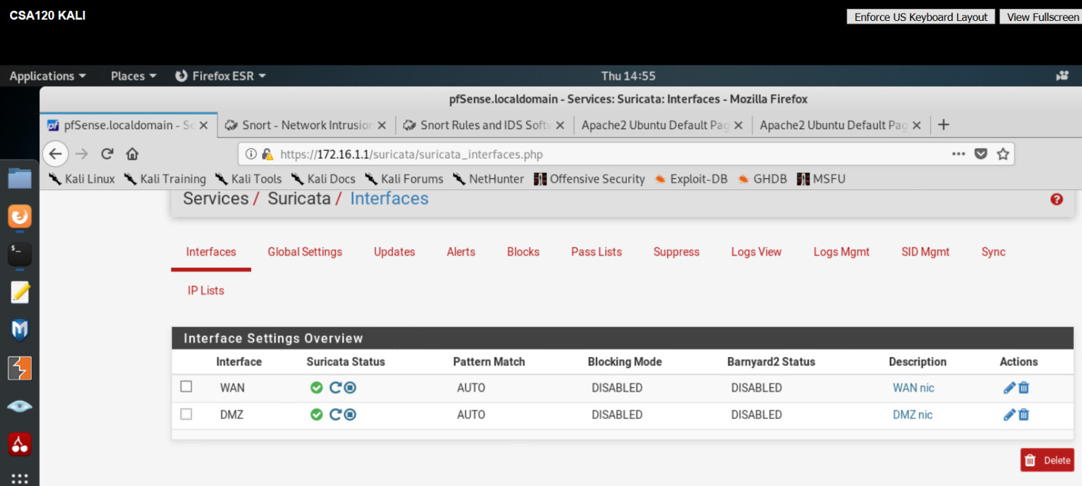

A day later I had these alerts for WAN

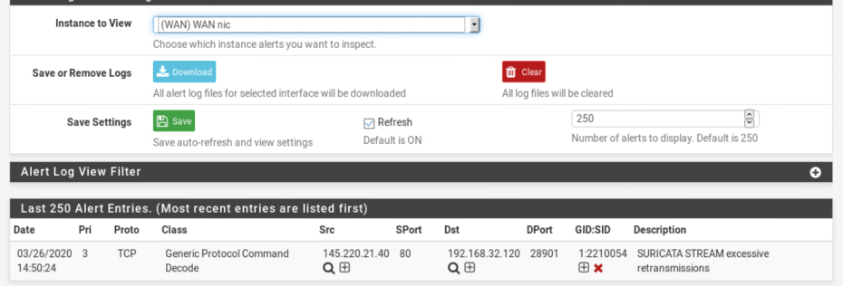

And these for my DMZ

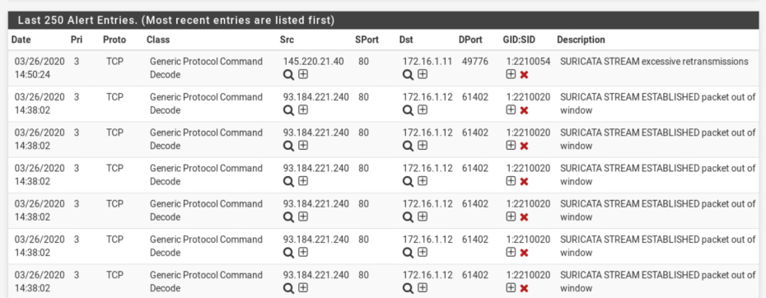

I later found out that these where just updates and useless for my goal. So, I decided to try to add my own rules to see if It even works. By following the guide for adding your own rules, I added rules for visiting the webserver with the message “OMG! Someone visited the web server!!!”

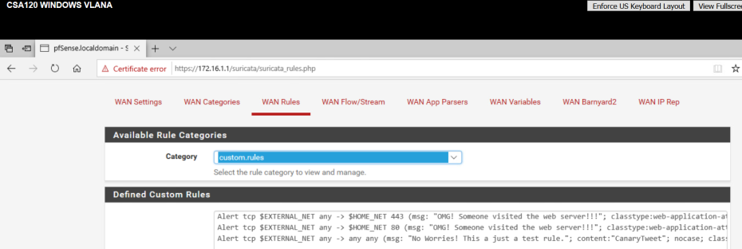

After creating the rules, I visited my webserver to see if it would give me an alert. And it did as seen in the image bellow.

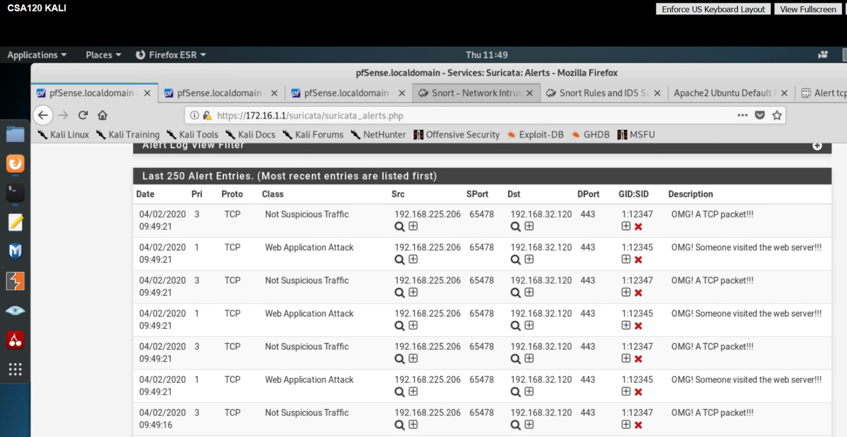

## What have I learned?

I learned about IDS, IPS and HIDS. By following the instructions, I was also able to learn a bit about creating my own rules for my systems. This was at first a bit confusing since I did not really understand the snort rules. But after doing a bit more reading and adding my own rule I understood it better. Also, a good thing to note is that this setup will only alert if things go through the firewall. This means that when a device on VLANB connects to another device on VLANB it will not track anything.

# VPN

## Prior knowledge

I knew a bit about VPNs since I had to use cisco AnyConnect for CSA and for CSB. I did not exactly know how it worked though. Just kind of what they did for me.

## Task

For the VPN I started with following the video (Ceos3c, 2018) and reading through canvas (Fontys, n.d.). At first, I did everything on Vlan A but after I almost finished, I realised it had to be setup on Vlan B, so I had to do it all over again. Most screenshots are for the Vlan A setup, but I made different screenshots for the IPs when I made the Vlan B setup.  
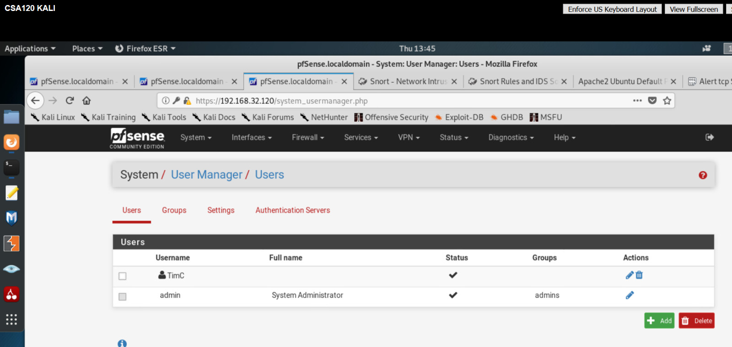  
I started with creating a new user to eventually login with. I named the user TimC at first but in later images you will see that I changed it to tim when I did the setup for Vlan B.

After creating the user, I created 2 Certificates one for the user and one for OpenVPN. This will help with creating a more secure VPN setup.  
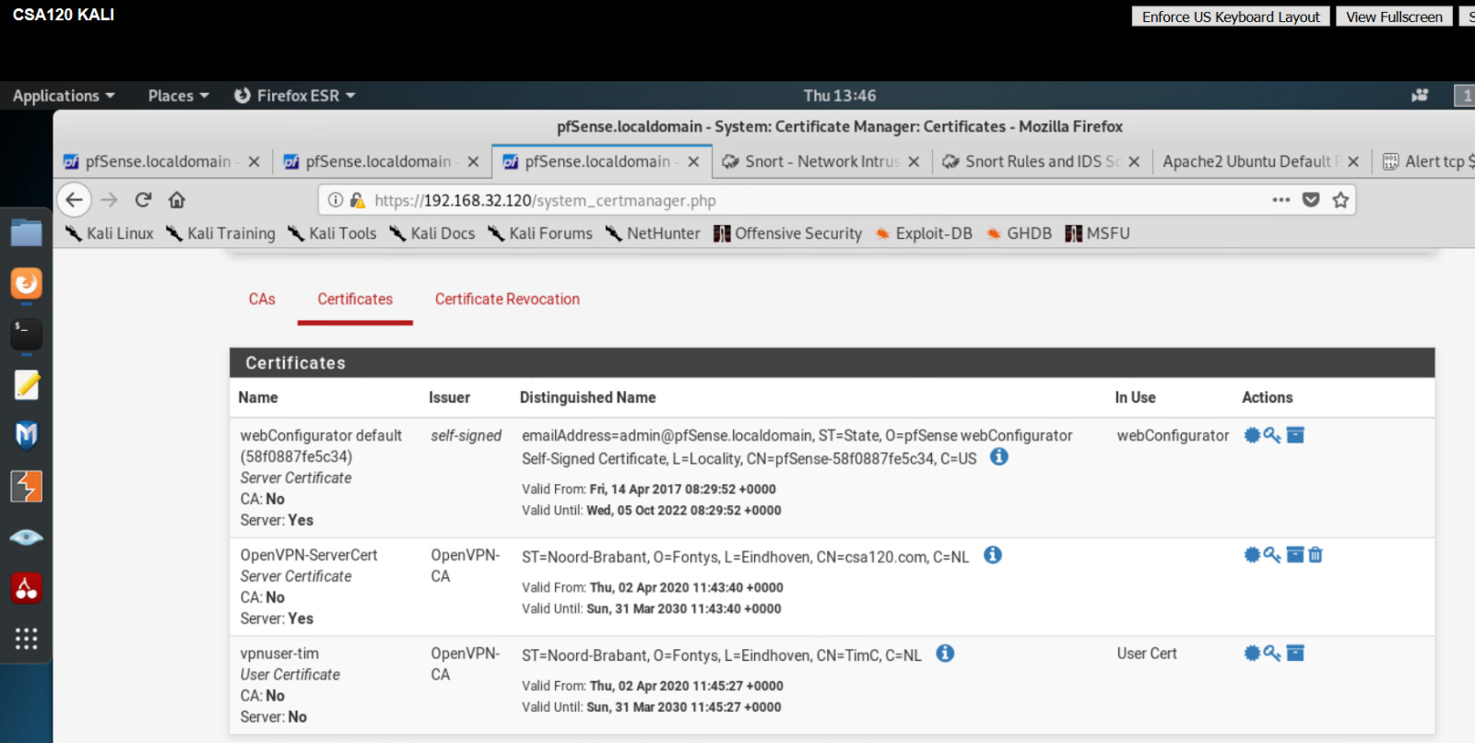

When that was done, I had to continue the setup with the openvpn-wizard. From here I had to pick the tunnel and the local network. We will see the tunnel networks use once we use the VPN. “a tunneling protocol is a communications protocol that allows for the movement of data from one network to another. It involves allowing private network communications to be sent across a public network (such as the Internet) through a process called encapsulation.” (Tunneling protocol, 2020)

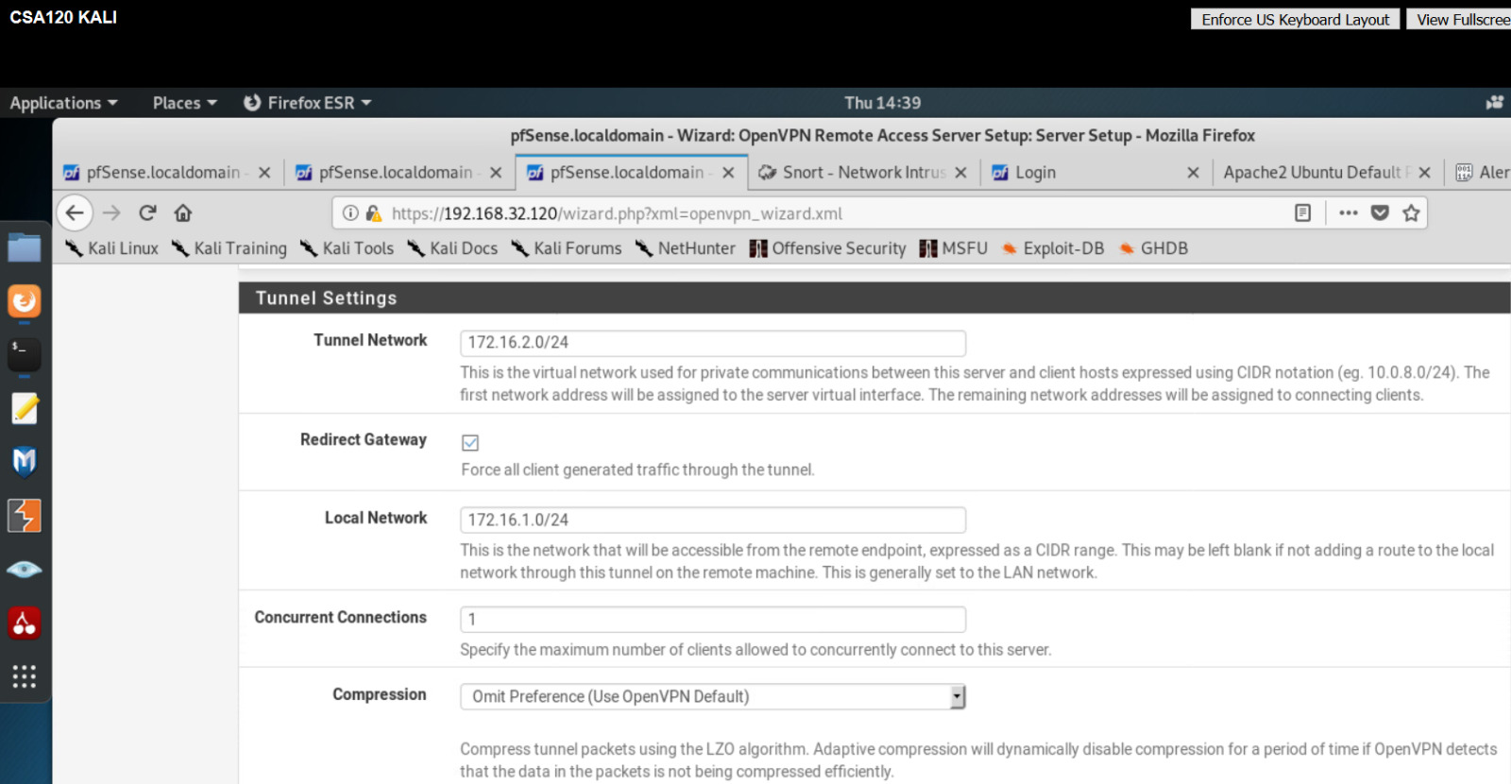

I also setup to just have 1 concurrent connection since I will not be having multiple users for now.

The last thing I had to do for the wizard setup was adding the DNS server and the default domain.   
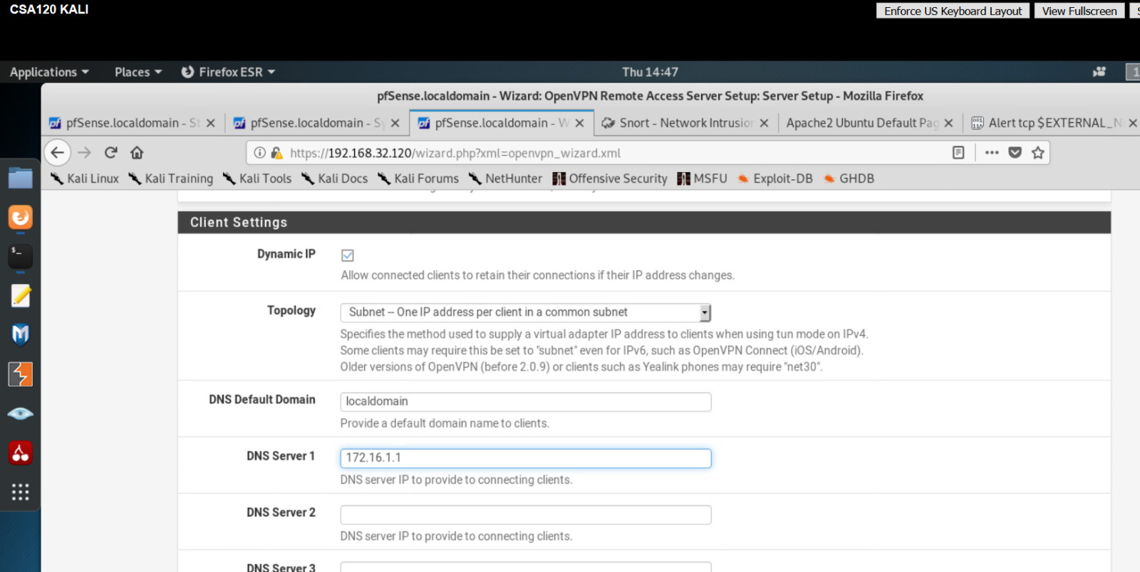

And the final thing for the overall step was creating a port forward for OpenVPN. With the NAT IP for my internal firewall.

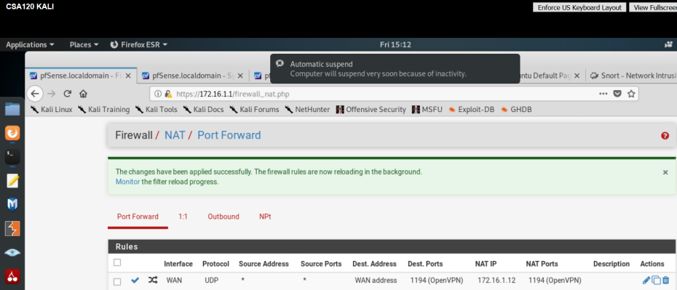

Now all I had to do was install OpenVPN, on my windows and switch from Vlan B to Vlan32 to check if it really works.

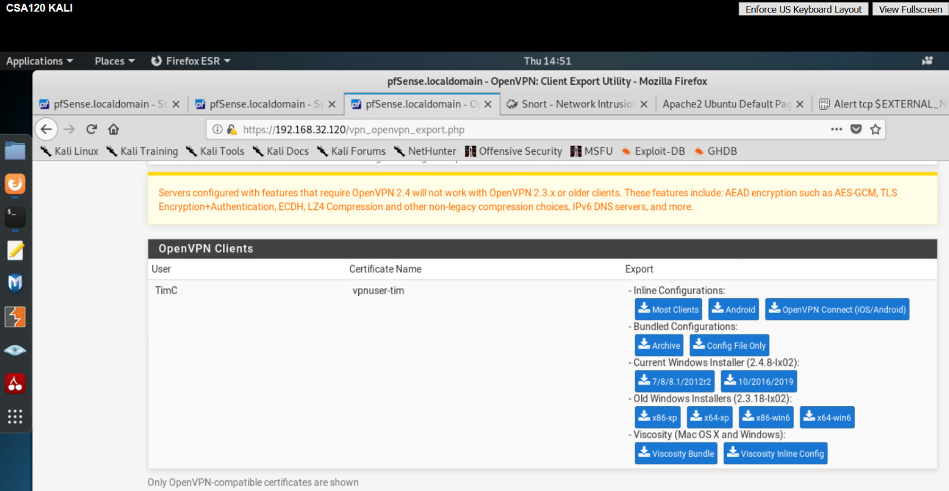

As seen in the image bellow my windows VM uses a unknow adapter with the IP 172.16.8.2

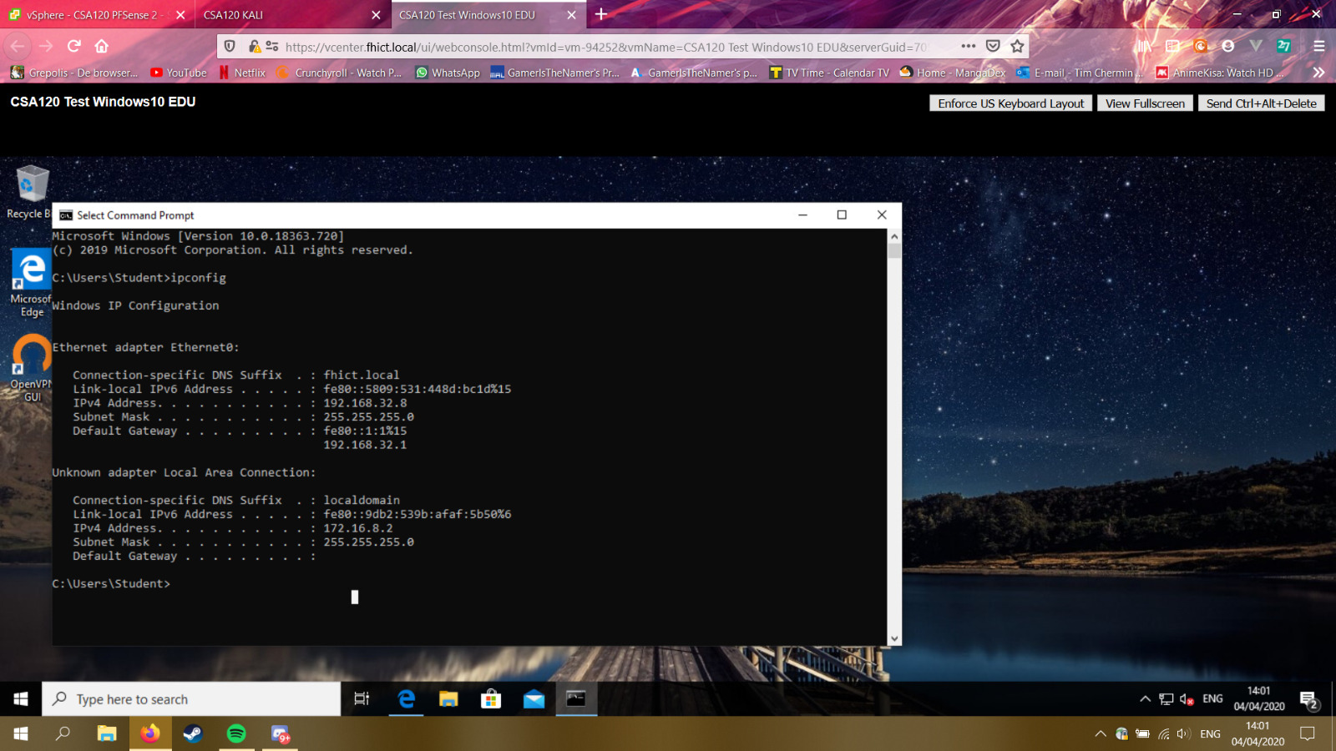

## What have I learned?

It was cool seeing my vpn finally working! At first, I did everything on my border firewall by accident instead of my internal firewall. When I had it installed on my border firewall it was not working and I had to investigate the OpenVPN logs when I realised that I was on the wrong firewall. After I switched to the internal firewall and setup everything again, it finally worked.

# IT Monitoring

## Prior knowledge

Before this subject I did not know anything about monitoring.

## Task

I started with readying on canvas (Fontys, n.d.) and watching the video (nagiosvideo, 2019)  
After watching and reading those I continued with the easy start guide (Fontys, 2019)  
I added the template for Nagiosxi and started with the basic setup.

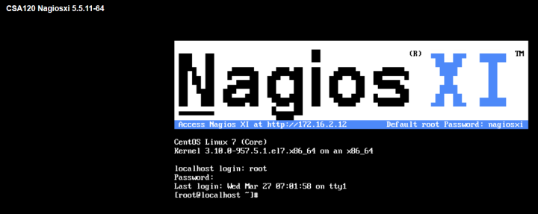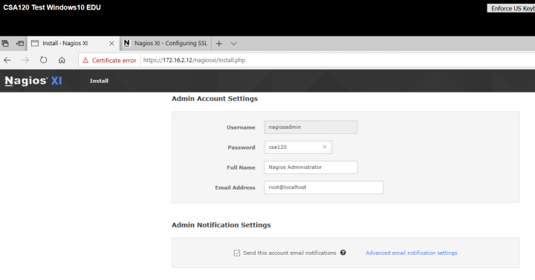

Once I logged in, I started with adding a new auto-discovery job this would automatically discover addresses/devices on the target range.

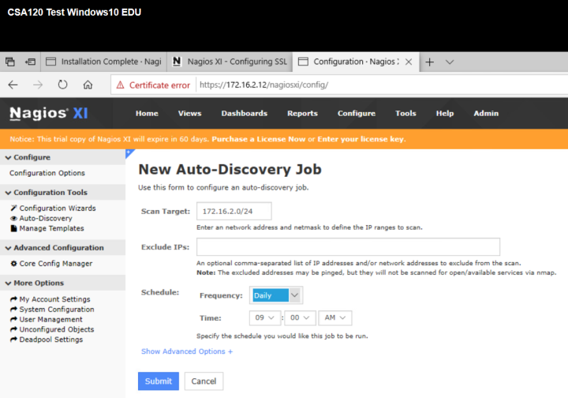

I setup 1 for once and 1 daily to check if everything is working as it should.

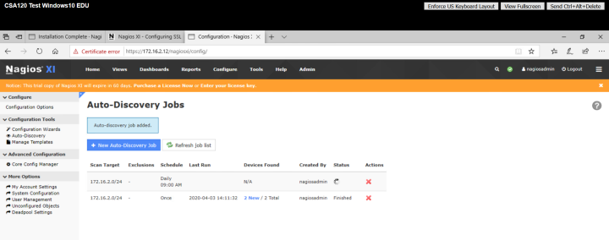

The once discovery found 2 addresses: my pfSense and the nagiosxi Linux server.

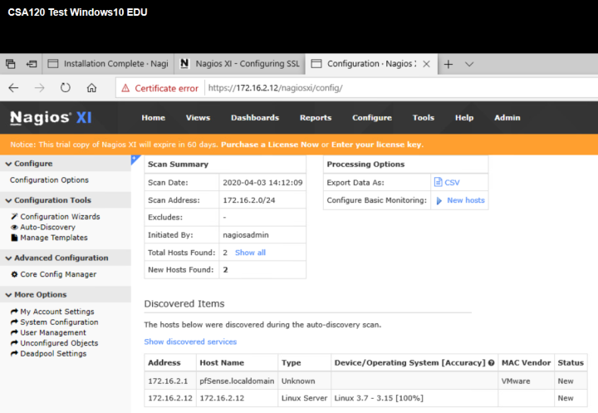

With that done the instruction in the pdf told me to set a static ip for my Nagios

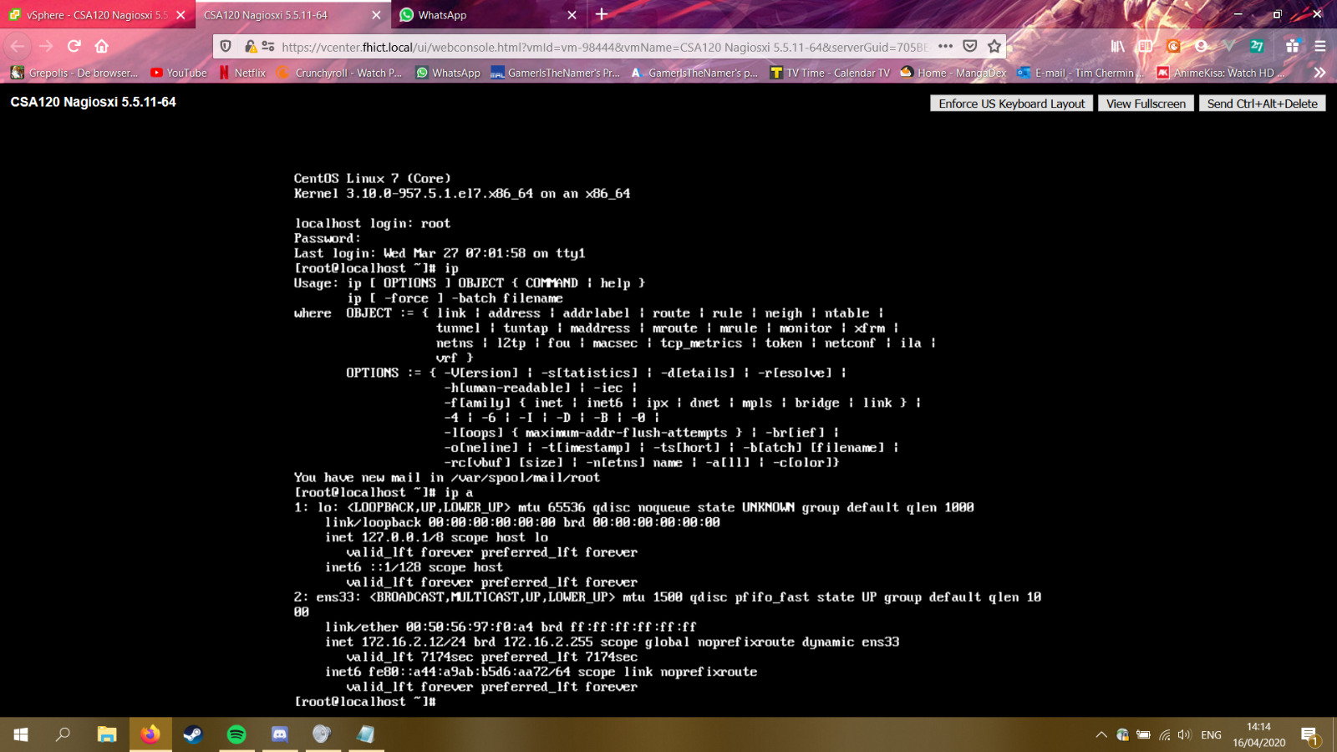

So, I change it to be static with the IP172.16.2.12 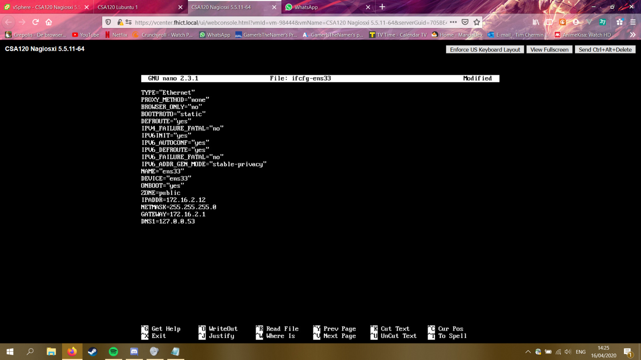

The reason I needed to do this was because the NRPE plugin

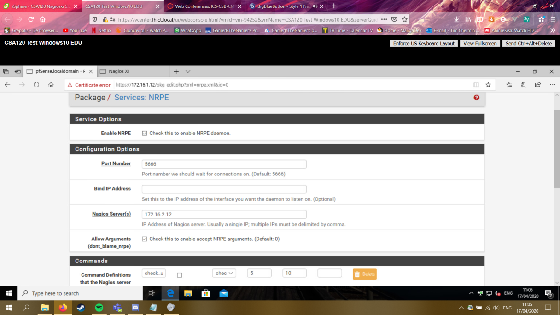

After some configuration I was also able to see pfSense in the host status tab.

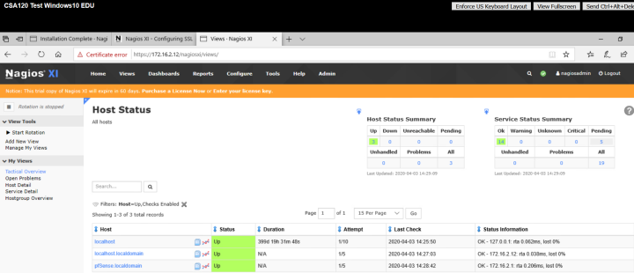

## What have I learned?

I learned how to setup NagiosXI and how it discovers and monitors my firewalls. I also learned to add plugins to connect it to NagiosXI, but I have not found out how what it does exactly to be honest.

# Overall Conclusion

The level of security in the end is not insanely high. Since there are still multiple things that can be done to improve it. The basics are setup and are doing what they should be doing. But for example, I could still work on IT Risk Analysis and IT System Defence.

# Reflection

I feel like I learned a lot about the defensive side of cybersecurity, and I could probably keep on learning things daily for my whole life and still do not know everything. But I think I got most of the basics and that is what I wanted in the first place. I personally prefer trying things out myself first over asking questions, but this probably made it a bit harder in the end. But since I worked together with Ensar and Wessel a lot we could try things out a bit more efficient. I also found it a bit more difficult to contact teachers even though they all told me to just msg them on teams, I think it was because I was not really used to working at home this much.

Even when working from home I find it hard to not work from 8:45 until 16:00 or later. When I am in the middle of something, I don’t want to be thinking about it too much when I’m not working on it. I wanted to change this semester a bit compared to CSB. When I did CSB I felt like I added a lot of unnecessary sentences to kind of get more of a total in words. So, I did not really want to do that this time and I tried to show more instead of writing more. I feel like I still have not really found the balance between the two, but I got to see both sides of it now at least.

Overall, I enjoyed setting up a network, but I am probably never going to do it again in my life.

# Bibliography

Ceos3c. (2018, October 31). *pfSense 2.4 OpenVPN setup Foolproof step-by-step!* Retrieved from youtube: https://www.youtube.com/watch?v=dBOQnApxzzQ&feature=youtu.be&t=469

Computer Hope. (2017, December 29). *NIDS*. Retrieved from computerhope: https://www.computerhope.com/jargon/n/nids.htm

*explanation basic knowledge assignment*. (n.d.). Retrieved from fhict.instructure: https://fhict.instructure.com/courses/9462/pages/explanation-basic-knowledge-assignment?module_item_id=466732

Fontys. (2019, April). *Easy Start with nagios XI*. Retrieved from protal fhict: https://portal.fhict.nl/Studentenplein/LMC/1920vj/Cyber%20Security/CSB/007_%5BReference%5D_IT_Monitoring/Easy%20Start%20with%20Nagios%20XI%202019.pdf

Fontys. (n.d.). *Intrusion Detection and Prevention (IDS/IPS)*. Retrieved from fhict.instructure: https://fhict.instructure.com/courses/9462/pages/reference-intrusion-detection-and-prevention-ids-slash-ips?module_item_id=466745

Fontys. (n.d.). *IT Monitoring*. Retrieved from fhict.instructure: https://fhict.instructure.com/courses/9462/pages/reference-it-monitoring?module_item_id=466746

Fontys. (n.d.). *reference network seperation and segmentation firewalls*. Retrieved from fhict.instructure: https://fhict.instructure.com/courses/9462/pages/reference-network-separation-and-segmentation-firewalls?module_item_id=466741

Fontys. (n.d.). *reference-introduction-into-defensive-it-and-information-security-concepts*. Retrieved from fhict.instructure: https://fhict.instructure.com/courses/9462/pages/reference-introduction-into-defensive-it-and-information-security-concepts

Fontys. (n.d.). *Secure Remote Acces and Management (VPN)*. Retrieved from fhict.instructure: https://fhict.instructure.com/courses/9462/pages/reference-secure-remote-access-and-management-vpn?module_item_id=466744

Gale, A. (2016, September 8). *Establish an incident Management plan*. Retrieved from cybersecurityresources: http://cybersecurityresources.org/article/oWEQMdW

nagiosvideo. (2019, April 2). *How SNMP Works*. Retrieved from youtube: https://www.youtube.com/watch?v=2IXP0TkwNJU

*reference security incident management*. (n.d.). Retrieved from fhict.instructure: https://fhict.instructure.com/courses/9462/pages/reference-security-incident-management?module_item_id=466743

Roijers, S. (2020, February 20). *Firewalls, proxies and application level filtering*. Retrieved from portal.fhict: https://portal.fhict.nl/Studentenplein/LMC/1920vj/Cyber%20Security/CSB/002_[Reference]_Network_Separation_and_Segmentation_(Firewalls)/pfSense%20firewall%20practical%202020%20v1.4.pdf

Roijers, S. (2020, March 1). *From crypto till HTTPS*. Retrieved from protal.fhict: https://portal.fhict.nl/Studentenplein/LMC/1920vj/Cyber%20Security/CSB/003_[Reference]_Secure_Network_Connections_(HTTPS-SSL-SSH)/Exercise%20HTTPS.pdf

Roijers, S. (2020, March 1). *Safe network connections exercise*. Retrieved from portal.fhict: https://portal.fhict.nl/Studentenplein/LMC/1920vj/Cyber%20Security/CSB/003_[Reference]_Secure_Network_Connections_(HTTPS-SSL-SSH)/Exercise%20SSH.pdf

*Studentenplein*. (n.d.). Retrieved from portal.fhict: https://portal.fhict.nl/Studentenplein/LMC/1920vj/Forms/AllItems.aspx?RootFolder=%2FStudentenplein%2FLMC%2F1920vj%2FCyber%20Security%2FCSB%2F002%5F%5BReference%5D%5FNetwork%5FSeparation%5Fand%5FSegmentation%5F%28Firewalls%29&FolderCTID=0x0120009DBFDDF4309

*Tunneling protocol*. (2020, April 3). Retrieved from wikipedia: https://en.wikipedia.org/wiki/Tunneling_protocol

wikipedia. (2019, December 27). *Host-based intursion detection system*. Retrieved from wikipedia: https://en.wikipedia.org/wiki/Host-based_intrusion_detection_system

Wikipedia. (2020, February 19). *incident managment*. Retrieved from wikipedia: https://en.wikipedia.org/wiki/Incident_management_(ITSM)

Wikipedia. (2020, March 26). *Information security*. Retrieved from wikipedia: https://en.wikipedia.org/wiki/Information_security

# Notes:

**Network separation:**

Why?

* Security omdat als er 1 gehacked zou worden dan is de rest nog niet gehacked.
* Performance als alles op 1 netwerk zit dan wordt t trager omdat alles broadcast.

Waar plaats je firewalls

1. between a local network and external networks

2. on gateways to important subnets within the LAN

3. End-points user-device/server

Een groter netwerk met meer firewalls betekend niet gelijk dat het veiliger is, als de firewalls niet sterk zijn of niet goed opgezet dan kan het weinig nut hebben.

DMZ: zit een webserver in die met de buitenkant praat.

**Internal examples:** Data center, extranet, remote access, lab, desktop, wireless.

**External:** DMZ, server data center, remote access, test or staging, internet.

**Firewall rules/policies:** DMZ only accessible from the outside, not connected to internal network.

2 kinds of firewalls: **Stateless:** firewall filter, also known as an access.

**Stateful:** firewalls can watch traffic streams from end to end. Firewall might know what the intensions of the user is.

**Next-generation firewall:** NGFWs typically feature advance functions including application awareness, integrated intrusion prevention systems, identity awareness – user group control.

**Secure connections met crypto:**

Modern crypto: Password hasing, secure connections and transactions/commnications, encrtyped wifi, disk encryption, digitale signatures, digital money, cars.

Symmetrical encryption sender and receiver use the same key

Asymmetrical encryption: every user has a keypair consisting of a

public key

1. used for encryption.

2. check signatures

A private key:

1. used for decryption

2. place signature (signen)

**Never design your own crypto**

Just a firewall is not enough, majority of attacks comes from inside

Added value of IDS and IPS: additional monitor behind the firewall makes sense because of hoels in the firewall (open ports)

Attacks from within eg via infected systems vpn clients

Internal networks are often less protected

What is intrusion detection: intrusion detection suspicious behaviour on a network or on a system

IDS challenges: very difficult to accurately dtect a certain type of intrusion false positives and false negatives.

Perfect does not exist for IDS

Where is IDS network level NIDS and system or host level HIDS

Encryption limits force of NIDS. NIDS cannot check the last piece of communication. HIDS does, but only looks at one system, is expensive to rool out everywhere and may have an impact on the performance.

Sensor in each network segment.

Snmp

Monitoring

OID: object identifier everything on the devices that can be monitored has a n OID kind of like an ip.

OID can be found on product manuals.

MIB: management information base, txt fiel to translate OIDS to word based instead of nrs. You don’t have to use MIBs

sysuptime.0 to see the uptime.

Polling: network monitor connects to device on port 161 then notifying: device sends OID related message to monitor system port 162. These messages are also called traps, notifications or informas.

V3 more secure: uses password, username and has encryption. Not all devices support v3 though.

Risk analysis

Risk = probability x impact

Step1 in risk analysis: list of threats

You have threat actors and motivations for example cyberciminals are looking for a profit and thrill-seekers are looking for satisfaction

Probability: the probability of the threat occurring in the coming year, in a qualitative risk anayl unlikely likely very likely to appear in the coming year.

Risk analysiss frameworks: ISO, NEN, MAPGOOD, SPARK, COSO, SWOT and more